**1. .NET**

* The Microsoft .NET Framework is a platform for building, deploying, and running Web Services and applications. It provides a highly productive, standards-based, multi-language environment for integrating existing investments with next-generation applications and services as well as the agility to solve the challenges of deployment and operation of Internet-scale applications.
* Owned by Microsoft Corporation (NASDAQ: MSFT) is an American multinational corporation that develops, manufactures, licenses, and supports a wide range of products and services predominantly related to computing through its various product divisions. Microsoft was established on April 4, 1975. Microsoft started the development on the .NET Framework in the late 1990s
* **Architecture:**

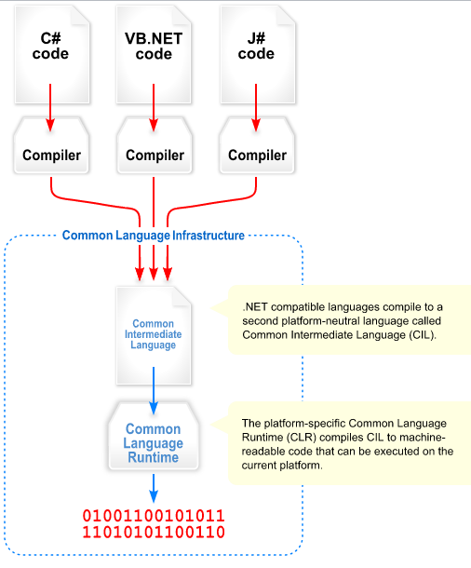

* **Version:**

|  |  |  |  |  |
| --- | --- | --- | --- | --- |
| Version | Version Number | Release Date | Visual Studio | Default in Windows |
| [1.0](http://en.wikipedia.org/wiki/.NET_Framework_version_history#.NET_Framework_1.0) | 1.0.3705.0 | 2002-02-13 | [Visual Studio](http://en.wikipedia.org/wiki/Visual_Studio) .NET | Windows XP Tablet and Media Center Editions |
| [1.1](http://en.wikipedia.org/wiki/.NET_Framework_1.1) | 1.1.4322.573 | 2003-04-24 | Visual Studio .NET 2003 | Windows Server 2003 |
| [2.0](http://en.wikipedia.org/wiki/.NET_Framework_2.0) | 2.0.50727.42 | 2005-11-07 | Visual Studio 2005 | Windows Server 2003 R2 |
| [3.0](http://en.wikipedia.org/wiki/.NET_Framework_3.0) | 3.0.4506.30 | 2006-11-06 |  | Windows Vista, Windows Server 2008 |
| [3.5](http://en.wikipedia.org/wiki/.NET_Framework_3.5) | 3.5.21022.8 | 2007-11-19 | Visual Studio 2008 | Windows 7, Windows Server 2008 R2 |
| [4.0](http://en.wikipedia.org/wiki/.NET_Framework_4) | 4.0.30319.1 | 2010-04-12 | Visual Studio 2010 | Windows 7(Recommended) |
| [4.5](http://en.wikipedia.org/wiki/.NET_Framework_version_history#.NET_Framework_4.5_.28Upcoming.29) | 4.5.40805 | 2012-02-29 (consumer preview) | Visual Studio '11' | Windows 8, Windows Server 8 |

**2. J2EE**

* J2EE short for Java 2 Platform Enterprise Edition. J2EE is a platform-independent, building distributed object-oriented enterprise systems. The J2EE platform consists of a set of services, APIs, and protocols that provide the functionality for developing multitier, Web-based applications. J2EE written by Java
* Owned by Sun Microsystems, Inc. a company that sold computers, computer components, computer software, and information technology services. Sun was founded on February 24, 1982.
* **Architecture**:

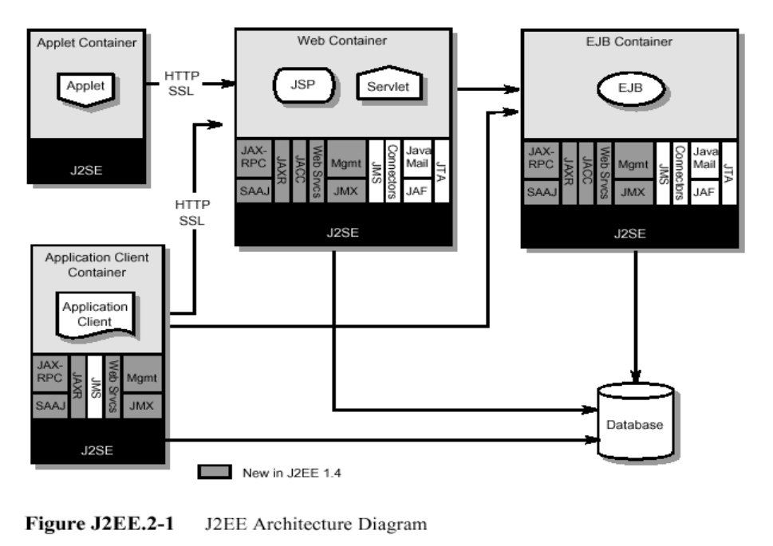

* **Version:**

|  |  |
| --- | --- |
| Version | Release Date |
| J2EE 1.2 | December 12, 1999 |
| J2EE 1.3 | September 24, 2001 |
| J2EE 1.4 | November 11, 2003 |
| Java EE 5 | May 11, 2006 |
| Java EE 6 | Dec 10, 2009 |

**3. Different between .NET and J2EE**

|  |  |
| --- | --- |
| .NET | Java |
| Designed to support multiple different programming languages. Currently, 30 languages support the .NET architecture. | Though other languages' code can be converted to run under JVM, they don't acquire true cross-language capabilities. |
| Compiles the source code to Intermediate Language (IL), which is itself a language. | Compiles the source code to Java bytecode, which by itself is not a language. |
| CLR implements a contiguous memory allocation algorithm. | JVM implements a noncontiguous memory allocation algorithm. |
| Compiles the source code twice during the process of converting to native code. Compiling works faster than interpreting. | Compiles and interprets the source code once during the process of converting it to native code. |
| Can only runs on Windows Operation System | Java is platform independent. This means that it will run on just about any operating system. |

**Source:**

<http://en.wikipedia.org/wiki/.NET_Framework>

<http://en.wikipedia.org/wiki/J2EE>

<http://en.wikipedia.org/wiki/Sun_Microsystems>

<http://en.wikipedia.org/wiki/Microsoft>

<http://edndoc.esri.com/arcobjects/9.1/ArcGISDevHelp/DevelopmentEnvs/DotNet/Introduction.htm>

<http://www.informit.com/articles/article.aspx?p=24924&seqNum=4>

“Software Architecture in Practice” by Len Bass, 2003